Title of the article should be written in compact, clear, and informative sentence, preferably not more than 20 words (16pt)
G Bush*, M M Angelo, J Little, E Hudson (11pt)
Department of ……………, Faculty of …….., University of ………… Street adress, City, Province, Postal code. Country (11 pt)
*Email: xxxxxxx@xxx.xx.xx (11 pt)
Abstract. A concise abstract is required (± 200 words). The abstract should be informative and state briefly the aim of the research, the principal results and major conclusions. An abstract is often presented separately from the article, thus it must be able to stand alone (completely self-explanatory). References should not be cited, but if essential, then cite the author(s) and year(s). Abbreviations should be avoided, but if essential, they must be defined at their first mention. (10 pt)
Keywords: 4 to 5 keywords excluding any word in title (10 pt)
- Introduction (11 pt)
Introduction is about 400-600 words, covering the aims of the research and provide an adequate background, avoiding a detailed literature survey or a summary of the results. Indicate the aims of research in the last paragraph. (11 pt)
Manuscript of original research should be written in no more than 8,000 words (including tables and picture), or proportional with articles in this publication number. Review articles will be accommodated, while, short communication should be written in about 2,000 words, except for pre-study.
Manuscript is typed on white paper of A4 (21 cm x 29,7 cm) size, in a single column single space, 11-point Times New Roman font, with margin text from the top is 4 cm, from the bottom is 2,7 cm, left and right are 2,5 cm. Smaller lettering size can be applied in presenting table and figure (11 pt). Word processing program or additional software can be used, however, it must be PC compatible and Microsoft Word based (.doc or .docx). Scientific names of species (incl. subspecies, variety, etc.) should be written in italic, except for italic sentence. Scientific name (genera, species, author), and cultivar or strain should be mentioned completely for the first time mentioning it in the body text, especially for taxonomic manuscripts. Name of genera can be shortened after first mentioning, except generating confusion. Name of the author can be eliminated after first mentioning. For example, Rhizopus oryzae L. UICC 524, hereinafter can be written as R. oryzae UICC 524. Using trivial name should be avoided, otherwise generating confusion. Biochemical and chemical nomenclature should follow the order of the IUPAC - IUB. For DNA sequence, it is better used Courier New font. Symbols of standard chemical and abbreviation of chemistry name can be applied for common and clear used, for example, completely written butilic hydroxytoluene (BHT) to be BHT hereinafter. Metric measurement use IS denomination, usage other system should follow the value of equivalent with the denomination of IS first mentioning. Abbreviations set of, like g, mg, mL, etc. do not follow by dot. Minus index (m-2, L-1, h-1) suggested to be used, except in things like “per-plant” or “per-plot”. Equation of mathematics does not always can be written down in one column with text, in that case can be written separately. Number one to ten are expressed with words, except if it relates to measurement, while values above them written in number, except in early sentence. The fraction should be expressed in decimal. In the text, it should be used “%” rather than “percent”. Avoid expressing ideas with complicated sentence and verbiage, and used efficient and effective sentence.
- Materials and Methods (11 pt)
Materials and Methods should emphasize on the procedures and data analysis. (11 pt)

Sub-Materials and Methods-1(11 pt)
The first paragraph does not need to use indent. (11 pt)
Second and subsequent paragraphs need to use indent.

Data Analysis
Xxxxx.
- Results and Discussion
Results and Discussion should be written as a series of connecting sentences, however, for manuscript with long discussion should be divided into subtitles. Results should be clear and concise. (11 pt)

Result
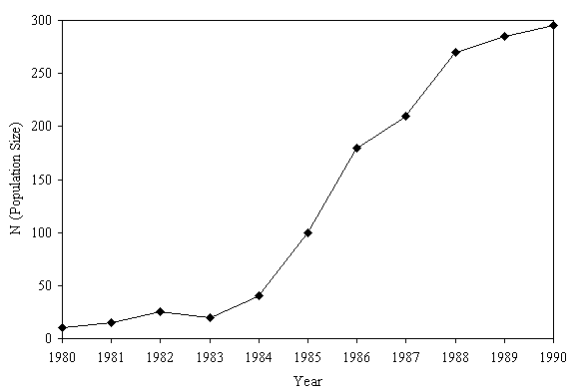
Figure 1. Figure example (11 pt)

Table 1. Table example (11 pt)
Cultivars | Parameter (Mean ± SD / SE)
 | Plant Height | Number of leaf
XXX | 00.00 ± 00.00 a | 00.00 ± 00.00 a
YYY | 00.00 ± 00.00 a | 00.00 ± 00.00 a
ZZZ | 00.00 ± 00.00 a | 00.00 ± 00.00 a
* Means followed by different letters are significantly different (Tukey HSD Test, α = 0.05)

Discussion
Xxxxx.
- Conclusion
The first paragraph does not need to use indent.
Second and subsequent paragraphs need to use indent.
- Acknowledgement
Acknowledgments are expressed in a brief; all sources of institutional, private and corporate financial support for the work must be fully acknowledged, and any potential conflicts of interest are noted. The first paragraph needs to use indent.

References
Journal
[1] Aoki H, Kuze N and Kato Y 2002 Food Ingredients Journal of Japan 199 41-45.

Book
[1] Borror DJ, Triplehorn CA and Johnson NF 1989 An introduction to the study of insects (United State: Saunders college publishing).

Thesis
[1] Abdullah T 2005 Kajian komunitas arthropoda dan serangan penggerek jagung asia, Ostrinia furnacalis Guenee (Lepidoptera: Pyralidae), pada pertanaman jagung (Indonesia: Bogor Agricultural University).

Internet
[1] Fulan 2021 http://www.contoh.com

